User Requirement Specification (URS)

Real-time Analytical Monitoring Application (RAM)

|  |  |  |  |
| --- | --- | --- | --- |
|  | |  | |
| Document Reference: | | RAM/TURS | |
| Project: | | Real-time Analytical Monitoring Application | |
| Document Title: | | Real-time Analytical Monitoring Application (RAM) User Requirement Specification (URS) | |
| Version: | | 1.0 | |
| Date: | | 13 April 2018 | |
| Author:  Reviewers:  Approved and Signed off by: | | Balasubramanian Narasimhan (PT07 ISS)  Kaung Myat Bo (PT07 ISS)  Treza Bawm Win (PT07 ISS)  Gao Zhiyu (PT07 ISS)  Nay Lin Aung (PT07 ISS)  Vincent Agnes Evangelin (PT07 ISS)  <PH> (SERIS) | |
|  | |  | |
|  | |  | |
|  | |  | |
|  | |  | |
|  | |  | |
|  | |  | |
|  | |  | |
|  | |  | |
| **©** 2001  The information contained in this document is the property of ISS. The contents must not be copied in whole or in part for purposes other than which it has been supplied without the consent of ISS, or, if it has been furnished under contract to another party, as expressly authorised under that contract, then ISS shall not be liable for any errors or omissions. |  |
| ***Institute of Systems Science, 25 Heng Mui Keng Terrace,***  ***Singapore 119615*** | |

Version History Record

|  |  |  |  |
| --- | --- | --- | --- |
| Version | Review & Approval Form Number | Date | Brief description of amendments and affected pages, paragraph |
| 1.0 | RAM/TURS | 18/4/2018 | First Issue |
| 2.0 | RAM/TURS |  |  |
| 3.0 | RAM/TURS |  |  |
| 4.0 | RAM/TURS |  |  |
| 5.0 | RAM/TURS |  |  |

Table of Contents

1. INTRODUCTION 5

1.1 Background 5

1.2 Objectives 5

1.3 Organization 5

1.4 Scope 5

1.5 Definition of Terms 5

2. OVERVIEW OF REQUIREMENTS 8

2.1 Introduction 8

2.2 System Perspective 8

2.3 System Functions 9

2.4 User Characteristics 10

2.5 General Constraints 10

3. FUNCTIONAL REQUIREMENTS 11

3.1 Processing Requirements 13

3.2 User Interface Requirements 25

3.3 Data Initialisation and Storage Requirements 40

4. OPERATIONAL and Quality REQUIREMENTS 41

4.1 Operating Environment 41

4.2 Development Constraints 41

4.3 System Interfaces 42

4.4 Performance 43

4.5 Reliability 43

4.6 Availability 43

4.7 Capacity and Expandability 43

4.8 Security 43

4.9 Future Growth 43

# INTRODUCTION

## Background

The Solar Energy Research Institute of Singapore (SERIS) conducts research, development, testing and consulting on solar energy technologies and their integration into power systems and buildings. SERIS is globally active but focuses on technologies and services for tropical regions, in particular for Singapore and South-East Asia.

The aim of the project is to develop a cloud-based platform for integrating and managing real-time Analytical Monitoring of PV systems performance - from small rooftop systems to large ground-based PV power plants in the multi-MW range across different climate zones. Collected data will be used for extensive research programmes on yield projections, which are of vital importance to project developers as well as investors and degradation studies of PV modules & systems.

The work is organized in 3 different projects

1. Web portal – A web portal for users to access the application components
2. Central Data Management – A cloud based application that can record, transform and report the data sent from PV systems.
3. SERIS Interface – The interface between the application and SERIS central monitoring system which. This interface enables communication and interaction between the proposed application and the SERIS Central Monitoring system

This document is to present the user requirement specification for the Real-time Analytical Monitoring Application – RAM, i.e. the project

## Objectives

The objectives of this document are to:

1. define the functional requirements for the Real-time Analytical Monitoring Application;
2. define the non-functional (i.e. operational and quality) requirements that would be necessary to support the functional requirements;
3. identify the necessary requirements that would facilitate the future modification of the application and
4. Provide the basis for the development of the system.

## Organization

Section 1 gives an introduction to this document. Section 2 presents an overview of requirements for the system or application. The functional requirements are presented in Section 3 and section 4 describes the operational and quality requirements.

## Scope

This user requirement specification is solely concerned with the development of the Real-time Analytical Monitoring Application and identifying the necessary requirements that would facilitate the future modification of RAM application. For the purpose of this document the Real-time Analytical Monitoring Application is referred as the application or simply ‘RAM’ interchangeably but both refer to the same.

<PH><Out-of-scope>

## Definition of Terms

The following terms have special meanings within this document:

1. The word ***shall*** implies a mandatory requirement.
2. The word ***should***implies a desirable requirement.
3. The word ***will*** implies a mandatory requirement outside the scope of this document.
4. The word ***may*** implies a desirable requirement outside the scope of this document.

## Definitions, acronyms and abbreviations

The following terms have special meanings within this document:

* Acronyms and abbreviations
* SERIS – Solar Energy Research Institute of Singapore
* RAM – Real-time Analytical Monitoring
* RAMA – Real-time Analytical Monitoring Application
* PV – Photovoltaic, systems that converts solar energy into electrical energy
* IoT – Internet of Things
* CMS – Central Monitoring System, The SERIS/in-house central monitoring system
* Definitions
* Devices – The PV systems that are required to be monitored
* Sensors – The sensors attached to each of these devices that constantly measure certain characteristics.
* Station – A station holds a set of devices that needs to be monitored. These devices are said to be tagged to that specific station.
* Web Portal – The component of the system that can be accessed via a browser by end user
* Cloud Computing - Cloud computing is an information technology (IT) paradigm that enables ubiquitous access to shared pools of configurable system resources and higher-level services that can be rapidly provisioned with minimal management effort, often over the Internet. Cloud computing relies on sharing of resources to achieve coherence and economies of scale, similar to a public utility

# OVERVIEW OF REQUIREMENTS

## Introduction

The aim of the project is to develop a cloud-based platform for integrating and managing real-time Analytical Monitoring of PV systems performance - from small rooftop systems to large ground-based PV power plants in the multi-MW range across different climate zones. Collected data will be used for extensive research programmes on yield projections, which are of vital importance to project developers as well as investors and degradation studies of PV modules & systems. Following are the three main streams of the project

1. Web portal – A web portal for users to access the application components
   1. User Management
   2. Device and Station configurations
   3. Report configuration
2. Central Data Management – A cloud based application that can record, transform and report the data sent from PV systems.
   1. Data Capture – Cloud based components that captures and records the incoming data (unstructured) sent from sensors
   2. Transformation – Cloud based components that transform and records the unstructured data into structured data for further analytics and reporting purposes
   3. Reporting – Cloud based reporting component that performs back-end analytical calculations and make it available for both front-end reporting and as well as for interfacing with SERIS’s in-house central monitoring system
3. SERIS Interface – The interface between the application and SERIS central monitoring system which. This interface enables communication and interaction between the proposed application and the SERIS Central Monitoring system

## System Perspective

The current application is actually an incremental development of the whole application. They were developed as smaller increments to an existing code. One has to manually intervene and re-write most or part of the code as and when a new device is to be incorporated into SERIS landscape. This could be a simple configuration change which could involve minor changes to the existing code. On the other hand it could drive a drastic change to the existing code to suit to a specific new device to be introduced into SERIS landscape. The primary objective of the system is to have soft configurable parameters that allow introducing and integrating new devices with in the SERIS landscape. Following are some of the high level benefits to be delivered by the proposed system.

* Single and Centralized platform for users to process the structured data from remote stations.
* Automated data capture for the structured and semi structured parameters.
* Interface with other backend systems within the organization, in this integration with SERIS central monitoring system.
* Audit trail capability of the incoming data
* Transformation of unstructured data into structured data
* Analytical reporting of the stations and devices

## System Functions

System functions to be implemented are:

1. Browser Interface – Access to the application via standard browser interface
2. User Login
3. User access mapping – Allowing relevant components are exposed and are accessible by the user
4. Application Administration – Perform setup, configuration and other supervisory / administrative functions to be carried out by the administrators, primarily focused on application level components
5. User Management
6. User/Access control Mapping
7. Device Management
8. Device configuration Management
9. Station Management
10. Station configuration Management
11. System Administration – Perform setup, configuration and other supervisory / administrative functions to be carried out by the administrators, primarily focused on system / infrastructure level components
12. System Setup
13. System Configuration Management
14. Central Data Management
15. Data Capture
16. Transformation
17. Reporting
18. Interface to SERIS/Central Monitoring System

## System Characteristics

The system has below listed characteristics

* RAM to be built on Cloud technology to offer high degrees of agility and the ability to collect high volumes of data in real time
* RAM allows PV system device(s) to generate very high volumes of unstructured data. This could typically be unstructured data sent at every second and every minute interval(s) from a variety of devices and store it in Cloud Database. These devices are spread across various industrial and remote sites that will stream data into the application which is to be stored with in the cloud database infrastructure
* RAM allows admins to configure and incorporate cloud-based system to reduce the cost of maintaining servers, to avoid data losses and to simultaneously access the system from multiple internet connected devices (computer, tablet, mobile phone)
* A default admin (super-user) user account will be setup during the installation. The admin will come with a set of pre-configured rights and privileges. Unlike other user accounts this account cannot be deleted/deactivated from the system.

## User Characteristics

The users have below listed characteristics

* Users will the use the application via browser interface.
* A user can only login from at most one system at any point in time. Concurrent login for the same user is not allowed, in which case the previous session will be automatically logged out

## General Constraints and Assumptions

The following are certain general assumptions and constraints of the intended application.

* Base version of application with following set of interfaces will be available.
* All partner systems will provide the required interface to integrate with Cloud based Real-time Analytical Monitoring of Photovoltaic Systems.
* Required Hardware and Software infrastructure will be made available in SERIS. The server and database are stored, managed and maintained by the SERIS, which is also responsible for maintaining the system and ensuring its qualification.
* The Sensors and Readers is installed at the Remote site, but the software, server and database are hosted by the system. The data are collected, stored and managed by the system whilst the SERIS has access to the data through a secure web interface.
* Application Development would be done by the MTECH SE25-PT07.
* Sensors should have a built-in data storage capability so that they can also act as data loggers. Sensors continuously collect and buffer data, even during network outages and power cuts. The buffered data should then be sent to the host server when the connection is re-established.

<PH-Out-of-scope>

# FUNCTIONAL REQUIREMENTS

This section describes the functional requirements of the RAMA. Figure 1 below present an overview of the system, showing the main components of the application and the roles of the users. The functional requirements are structured in terms of:

1. Processing requirements – the main software application functions to be provided
2. User interface requirements – the required user interface to support the software functions.
3. Data initialization and storage requirements

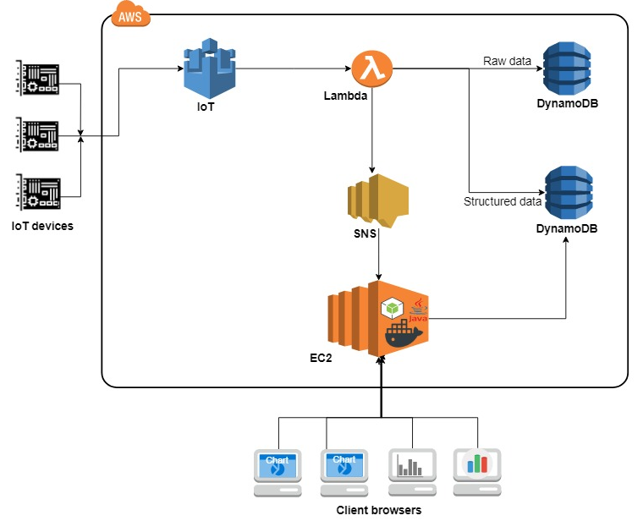

Figure 1: System Overview

The below is Requirements level Use Case Model for the Application for understanding the features application will provide.

## C:\Users\Bala\Desktop\Incr DOCs\Primary Use cases.png

### Browser Interface

### Users access the application’s web-portal via a standard browser interface with an active internet connection. The web-portal should be user-friendly and is capable of performing complex operations by accessing the data stored in the cloud.